Clean Water Raingers
Order Form

NJ Department of Environmental Protection

March 2013

Clean Water Raingers publications are available for educators and can be used in conjunction with other water education lessons. Educators are provided with free activity or coloring booklets and stickers for their elementary school age students. Student lessons, basic information and other resources can be found on the NJ Department of Environmental Protection website at www.cleanwaternj.org . The NJDEP Seeds website offers these publications and many other educational resources on the Department’s central environmental education web page http://www.state.nj.us/dep/seeds.
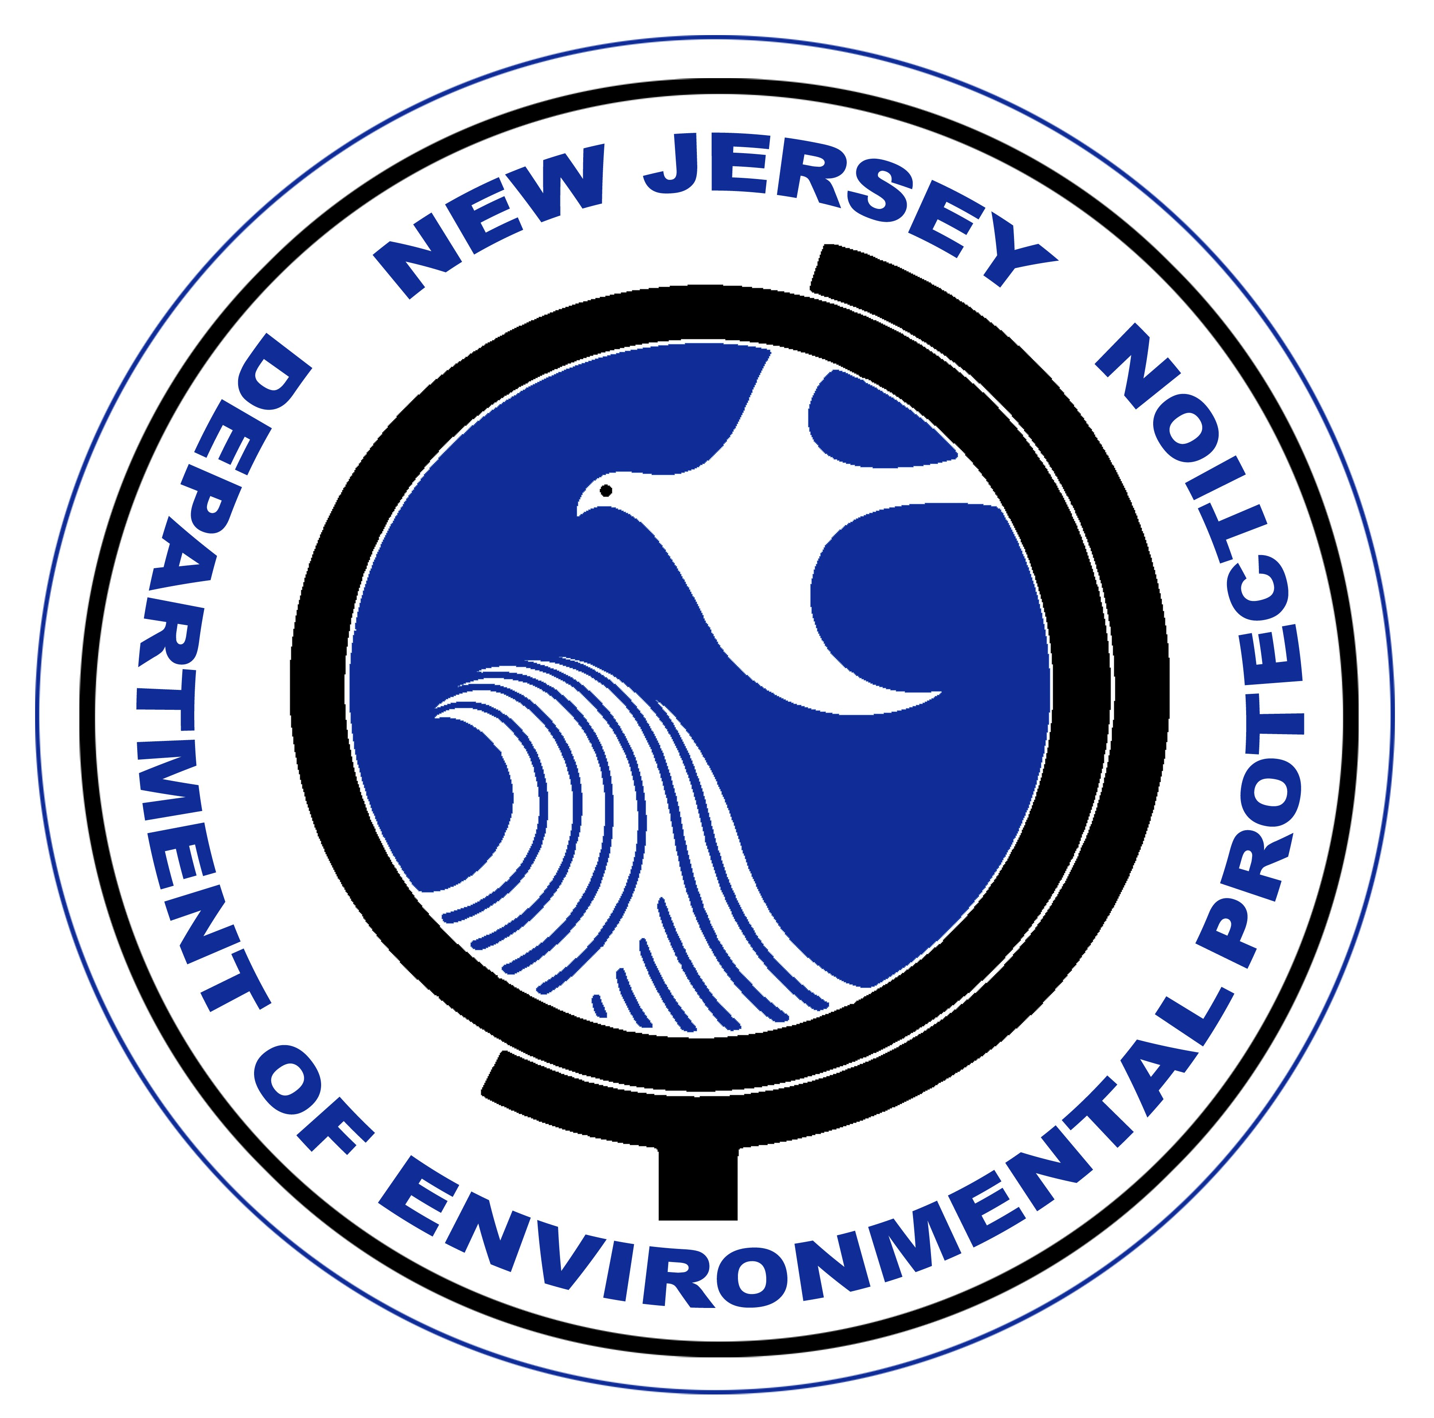
Please indicate quantity needed. Maximum is 100 copies per publication per request.
Clean Water Raingers Publications (Grades 1 through 6)

for students and educators
____ Clean Water Rainger Coloring Book (Grades 1-3)
____ Clean Water Rainger Activity Booklet (Grades 3-5)
____ Clean Water Rainger Stickers

Please indicate quantity needed. Maximum is 35 copies per publication per request.
NJ Project WET Publications
for students and educators
____ Watershed Protection Activity Booklet (Grades 1-5)
____ Discover Storm Water Activity Booklet (Grades 2-6)
____ Water Every Drop Counts Activity Booklet (Grades 3-8)

For more information or to place an order,
please contact:
1-866-DEP-KNOW

Communications Office
NJ Dept of Environmental Protection
Mail Code 401-04
Trenton, NJ 08625-0402

Name: _____________________________________________________________________

Organization: _______________________________________________________________

Address: ___________________________________________________________________

Town: _____________________________ State: _______ Zip Code: ___________________

Phone Number: ______________________________________________________________

Email Address: ______________________________ Date needed: _____________________

Many of our publications are online at our website at www.nj.gov/dep

